DISCOVERING YOUR GENETIC GENEALOGY
© Denise Anderson-Decina
d.anderson.decina@gmail.com
Rush County Genealogical Society (rcgsociety.org)
Virtual Presentation – 10 October 2020

GENETIC GENEALOGY - BASICS
- Chromosomes – 22 pairs of autosomal chromosomes (one from Mom and one from Dad) + X and Y sex chromosomes
- DNA Inheritance Patterns – recombination process creates a unique record of your ancestors
- Your testing goal: determining the correct test to take
- DNA Tests (autosomal (atNDA) + Y + mitochondrial (mtDNA); testing companies
- DNA Test Results: dna matches, relationships, ethnicity
- Genetic relationships identified by centimorgans (cMs) of shared matches
- DNA painter.com – relationship tool – how close is that match?

WAITING FOR DNA RESULTS
- Create or Update genealogical family tree; upload GEDcom file
- Search for family bibles, letters, records to construct family relationships in your tree
- Document tree with sources

UNRAVELING DNA RESULTS
- Start with what you know: common surnames, known cousin relationships, etc.
- Identify DNA matches by grouping: maternal, paternal, and unknown
- Examine shared matches to help sort out possible family lines – ancestors in common
- ThruLinesTM – visualize possible family tree relationships with connections to DNA matches
- Update your family tree based on identified DNA matches

DISCOVERING UNKOWN MATCHES
- Analyze genetic relationships; review shared matches; compare family trees
- Establish communications with potential matches; emotional side of DNA testing
- Finding unexpected “surprises” in DNA matches.

DNA TESTING COMPANIES
Ancestry | Ancestry.com/DNA | Autosomal test (atDNA) + traits + health reports
23andMe | 23andMe.com | Autosomal test + haplogroup + health reports
MyHeritage | MyHeritage.com | Autosomal test + health reports
FamilyTreeDNA | FamilyTreeDNA.com | Autosomal test (Family Finder), Y-DNA, mtDNA + health reports
LivingDNA | LivingDNA.com | Autosomal test

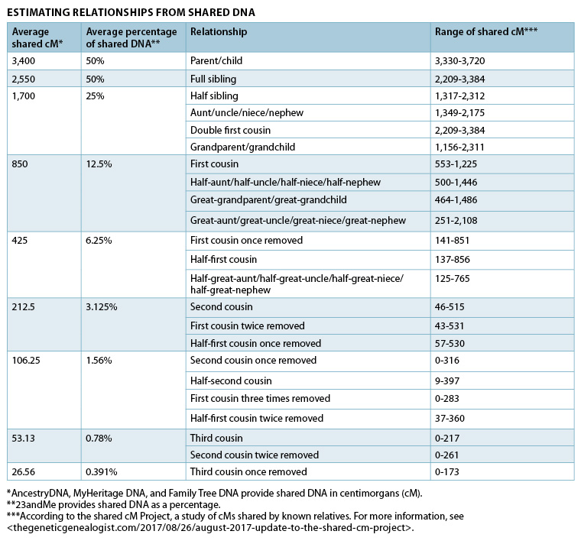
Excerpt from Family Tree Magazine, “How to Use Shared DNA to Determine Relationships”

